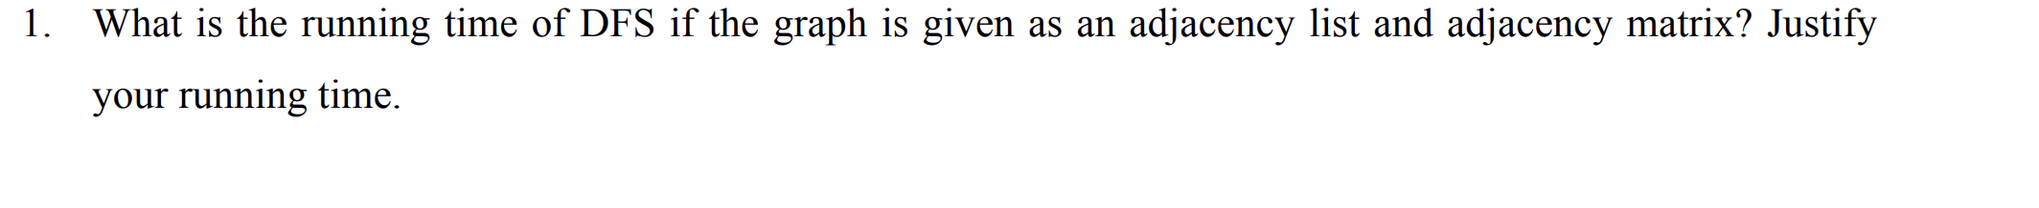

If the graph is given as adjacency list:

* Each node have a list of all its neightbour edges. Assume there is V nodes and E edges in the graph.
* We need to traverse its adjacency neighbours for each nodes.
* For a directed graph, the time complexity in this case is O(v) + O(E) = O(V + E)
* For a un-directed graph, each node appears twice, the time would be O(V) + O(2E) = O(V + E)
* If the graph is represented as an **adjacency matrix** (a V x V array):
  + For each node, we will have to traverse an entire row of length V in the matrix to discover all its outgoing edges. The Time complexity would be **O(V * V) = O(V ^ 2)**.



We can solve this problem using depth first search of the tree. While doing dfs we can observe a relation between the order in which we visit a node and its ancestors. If we assign in-time and out-time to each node when entering and leaving that node in dfs then we can see that for each pair of ancestor-descendant the in-time of ancestor is less than that of descendant and out-time of ancestor is more than that of descendant, so using this relation we can find the result for each pair of node in O(1) time.

def subsets(self, nums: List[int]) -> List[List[int]]:

res = []

subset = []

def dfs(i):

if i >= len(nums):

res.append(subset.copy())

return

subset.append(nums[i])

dfs(i+1)

subset.pop()

dfs(i+1)

dfs(0)

return res